Main

**-Requirements Specification:** Following statements are omitted ambiguous requirements for a Ticket Vendor Machine part of a Smart Ticketing System.

- An automated ticket-issuing system sells public transportation (Bus, MRT, etc..). Users select their destination and select the mode of payment (such as Credit Card, QR Code payment linked with banking system or digital wallet).

- In case of payment with credit card then the ticket vendor machine issues a paper ticket with a bar code itself and their credit card account be charged. When the passenger presses the start button, a menu display of potential destinations is activated, along with message to him/her to select a destination. Once a destination has been selected, he/she is requested to input their credit card. When the credit transaction has been validated, the ticket is issued.

- The same for digital wallet means that the ticket vendor machine will show a QR Code after the passenger selecting a route for her/his mobile phone payment.

**Answer:**

1. **Ask question to make a clear for above requirements and write them in the form of Excel (Q&A).**

*-What modes of payment are available for the digital wallet option?*

+The available modes of payment for digital wallet include mobile banking, e-wallets (such as Momo, VNPay, ZaloPay), and other digital payment platforms.

*-What happens if the credit transaction fails to validate?*

+If the credit transaction fails to validate, the system should provide an error message to the user and prompt them to try again or select an alternative mode of payment.

*-Are there any restrictions on the types of credit cards accepted by the system?*

+The system should accept all major credit cards, subject to any restrictions or conditions imposed by the relevant credit card providers and the system operator.

*-What is the expected response time for validating a credit transaction?*

+The system should validate credit transactions within 10 seconds or less, to ensure an efficient and reliable service for passengers.

*-Is there any limit on the number of tickets that can be purchased in a single transaction?*

+The system should allow passengers to purchase up to 5 tickets in a single t ransaction, to ensure efficient use of the system and to prevent delays for other users.

1. **Write a set of functional, non-functional and domain requirements for a Ticket Vendor Machine. You can conduct this exercise to Excel or Word. Remember to concentrate on expectations of reliability and response time.**

*-Functional requirements:*

+The ticket vendor machine should allow users to select their destination from a menu display.

+The system should support multiple modes of payment, including credit cards and digital wallets.

+When paying by credit card, the system should validate the transaction and issue a paper ticket with a barcode.

+When paying by digital wallet, the system should display a QR code on the screen for the user to scan.

+The system should limit the number of tickets that can be purchased in a single transaction.

+The ticket vendor machine should issue a receipt for each transaction.

+The system should keep track of ticket sales and revenue for reporting purposes.

*-Non-functional requirements:*

+The system should validate credit transactions within 10 seconds or less.

+The system should be available for use 24 hours a day, 7 days a week.

+The ticket vendor machine should be easy to use, with clear instructions and intuitive interface design.

+The system should be secure and protect users' personal and financial information.

+The system should be reliable and minimize downtime or system errors.

*-Domain requirements:*

+The system should comply with relevant laws and regulations related to public transportation and payment systems.

+The ticket vendor machine should be compatible with existing ticketing systems and infrastructure.

1. **Develop Use Case modelling for Ticket Vendor Machine, you are also encouraged to make Use Case Description for each use case on your use case diagram.**

*-Use case diagram:*

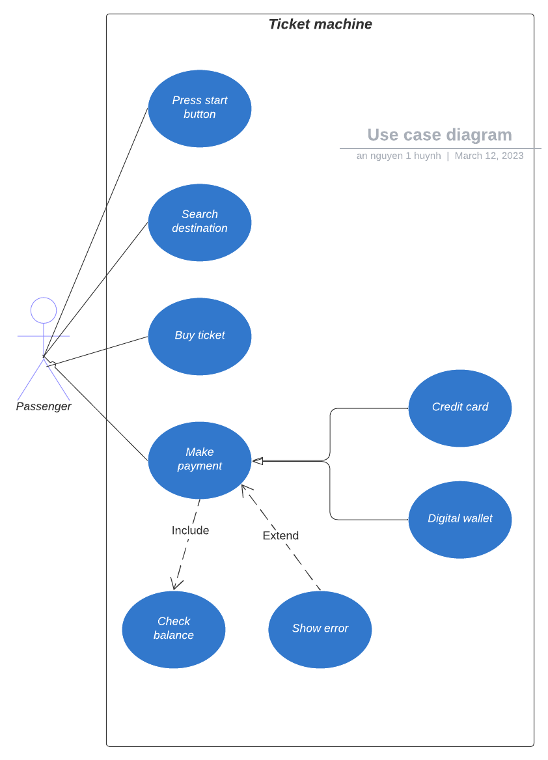

*-Description:*

+Use Case Name: Press start button:

Actors: Passenger

Description: The passenger press the start button to buy a ticket.

Pre-conditions: The ticket vendor machine is not ready.

Post-conditions: The ticket vendor machine is ready and the menu will show up.

Flow of events: The passenger press the button.

+Use Case Name: Buy a Ticket:

Actors: Passenger

Description: The passenger uses the ticket vendor machine to buy a

ticket.

Pre-conditions: The ticket vendor machine is functional.

Post-conditions: The passenger receives a ticket and the payment is processed.

Flow of events: The passenger selects their destination.

+Use Case Name: Buy a Ticket:

Actors: Passenger

Description: The passenger uses the ticket vendor machine to buy a ticket.

Pre-conditions: The ticket vendor machine is functional.

Post-conditions: The passenger receives a ticket and the payment is processed.

Flow of events: The passenger selects their destination.

+Use Case Name: Check Balance:

Actors: Passenger

Description: The passenger uses the ticket vendor machine to check their balance.

Pre-conditions: The ticket vendor machine is functional.

Post-conditions: The passenger receives their balance.

Flow of events: The passenger selects their mode of payment (Credit Card or Digital Wallet).

If Credit Card is selected:

The passenger inserts their credit card.

The ticket vendor machine validates the credit card.

If the balance is not enough:

Show the error message.

If the balance is enough:

The ticket vendor machine charges the credit card and issues a paper ticket with a barcode.

If Digital Wallet is selected:

The ticket vendor machine displays a QR code.

The passenger scans the QR code with their mobile phone.

The ticket vendor machine validates the bank balance.

If the balance is not enough:

Show the error message.

If the balance is enough:

The digital wallet deducts the payment and the ticket vendor machine issues a paper ticket with a barcode.

1. **Make an Activity diagram to present the process of passenger’s buying a ticket from ticket vendor machine (Look like ATM) and the activity diagram for communication among systems if your system is integrated with other system like Momo, VNPay, ZaloPay,...etc**

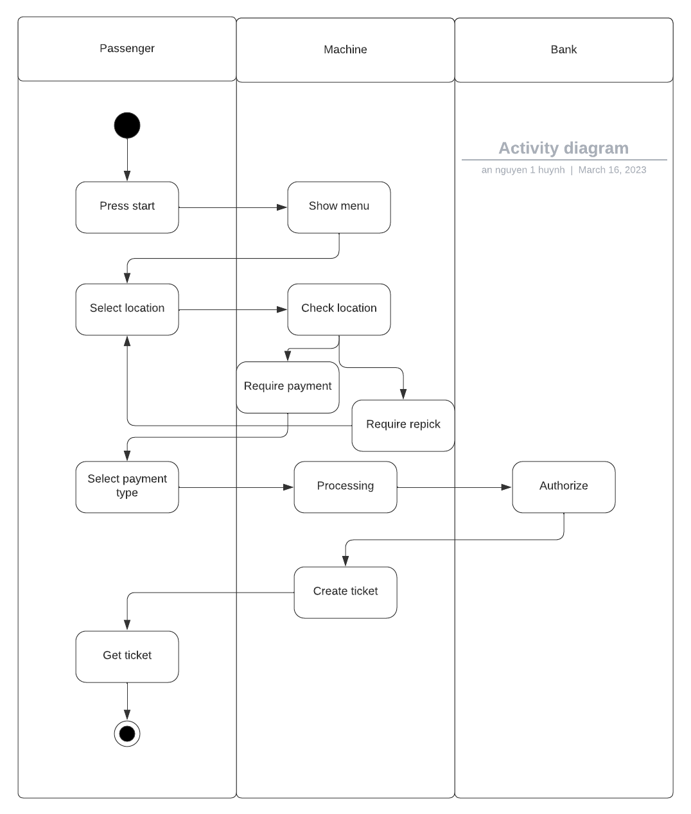

1. **Let’s say that the Ticketing Vendor Machine have main use case: Buy a ticket then you are required to complete the sequence diagram, State chart diagram, and Class diagram.**

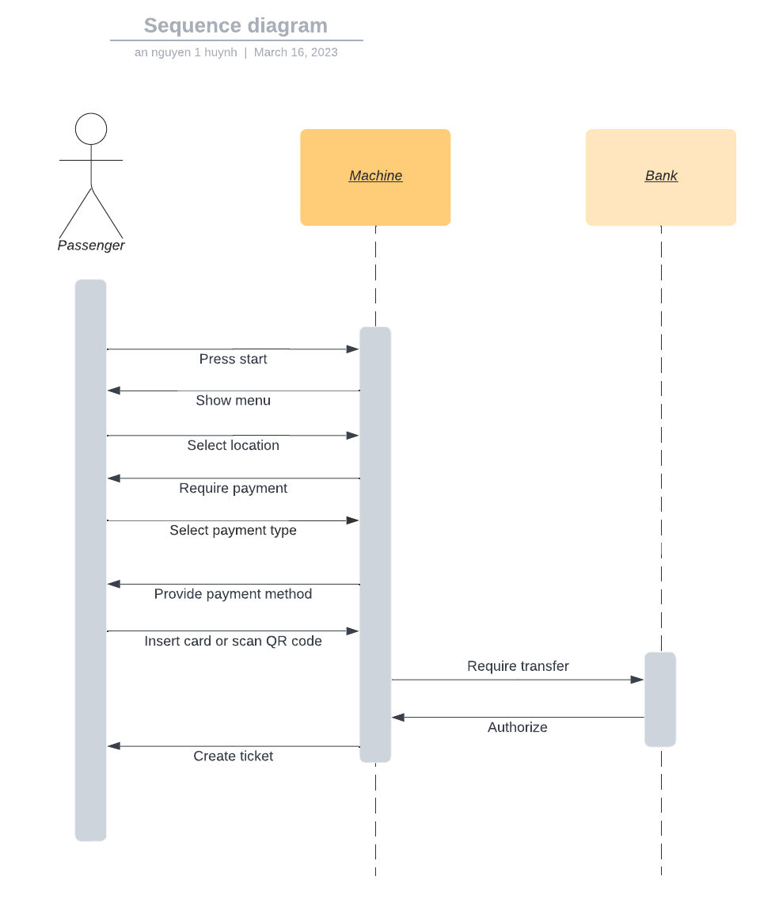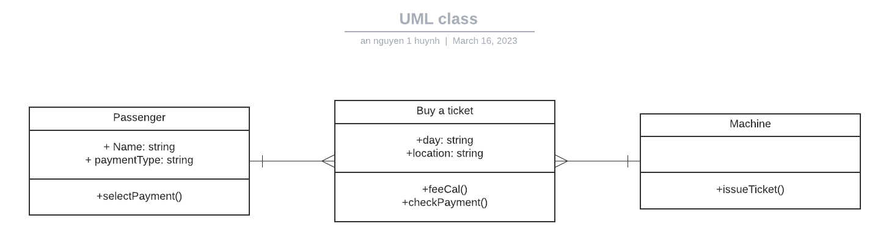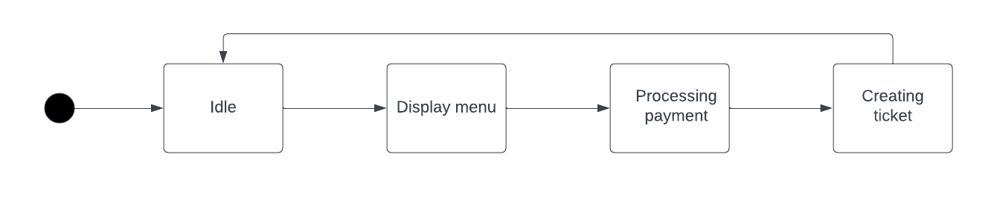

1. **Design an either wireframe/mockup with balsamiq or prototype with figma for your use cases.**

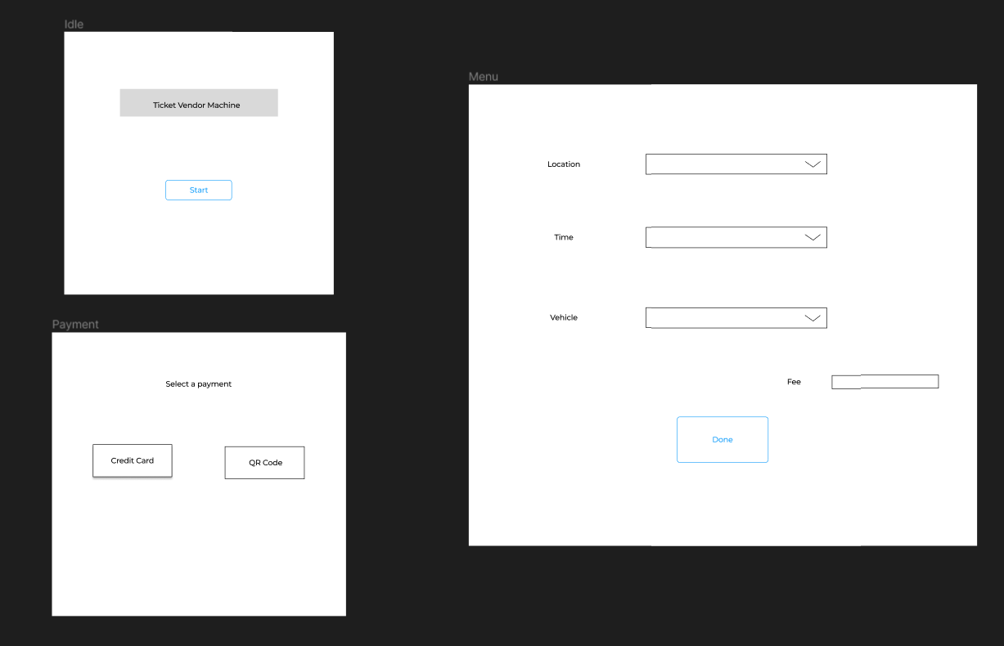

1. **Develop Architecture design (System in-a-box or MVC model) and Deployment diagram for Ticket Vendor Machine.**

**Deployment Diagram System in-a-box**

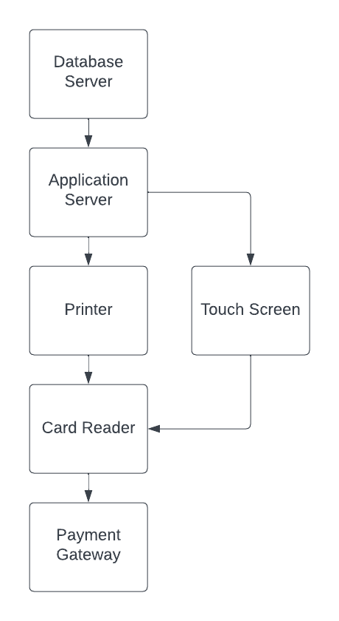 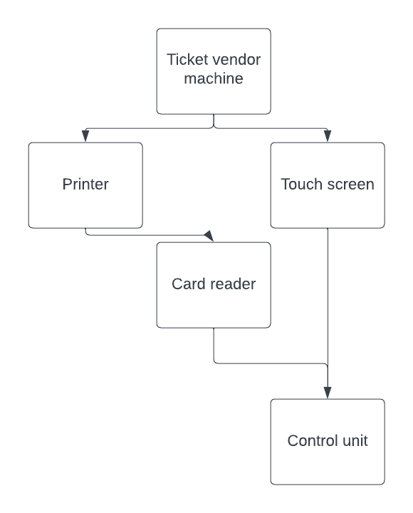

1. **Demo any use case (form for inputs, report for output) with Visual Programming C# and MSSQL.**

